QUESTION#1

Write the datatypes of the following values:

• “Introduction to IDE and basic programing constructs”

String

• 3.14

Float

• 300000000

Integer

• 7.0000000000005

Double

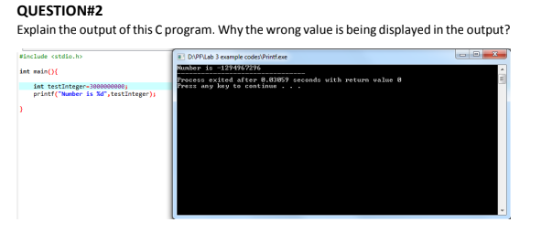

**Integer cannot store such a large value as a result overflow occurs.**

**QUESTION#3**

**Write a C program that takes two integer values as input from the user. Then swap the**

**values taken from the user and display the output of the variables.**

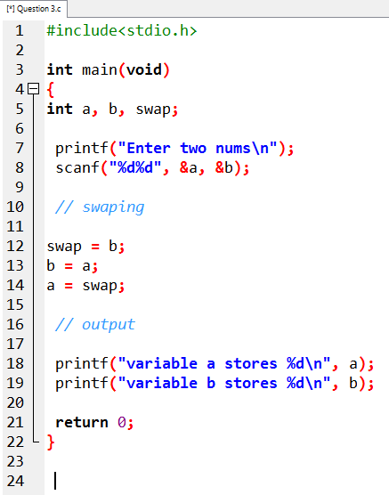

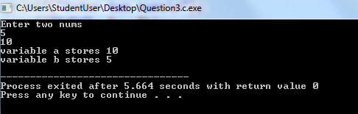

**QUESTION#4**

**A customer asks the IT firm to develop a program in C language, which can take tax rate**

**and salary from the user on runtime and then calculate the tax, the user has to pay and**

**the salary he/she will have after paying the tax. Tax rate must be between 0-100.**

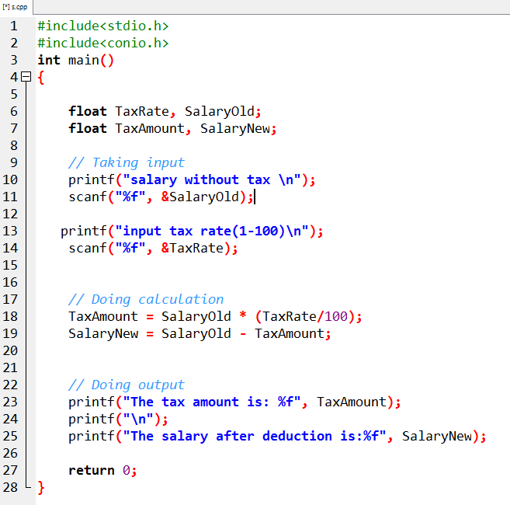

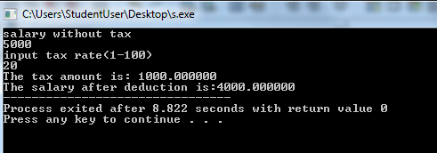

**QUESTION#5**

**A car traveled for some hours. The time car traveled is taken at run time of the program,**

**and it must not be negative and must be between one to five hours. The car had not**

**traveled same distance in each hour. The distance that the car covered must not be**

**negative. Write a C Program that computes the Average Speed of the Car in miles per hour.**

**Hint: the restrictions can be displayed in the form of message on the window.**

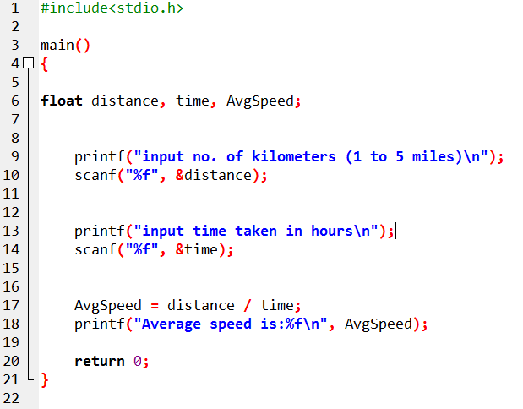

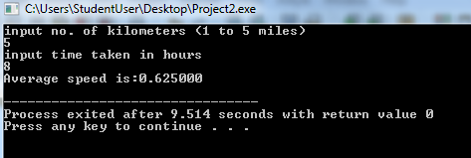

**QUESTION#6**

**A person travels 10 kilometers in south from his home to go to the university in car then**

**he travels 10 kilometers in west then he travels another 5 kilometers south and finally he**

**travels 15 kilometers in north with the fuel consumption of 3 liters/km. Calculate how far**

**away is his university from home and how much fuel he consumes daily in these two ways**

**trip?**

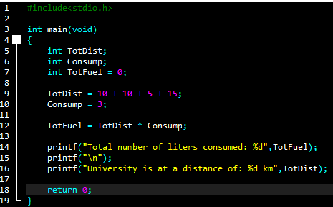

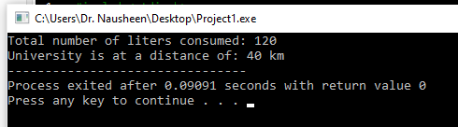

**QUESTION#7**

**Construct a C program with the flowchart below. The input value of the Principle must be**

**between 100 Rs. To 1,000,000 Rs. The Rate of interest must be between 5% to 10% and**

**Time Period must be between 1 to 10 years. Hint: these restrictions can be displayed in the**

**form of message on the window. Simple interest can be computed by using the formula**

**mentioned below.**

**Simple Interest=(P*R*T)/100**

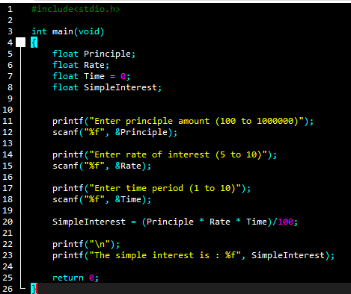

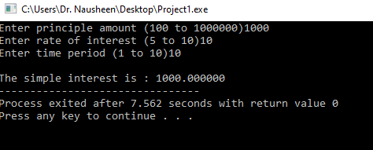

**QUESTION#8**

**Calculate the area for a rectangle in which user inputs width and length of a rectangle.**

**Formula: area of a rectangle=width * height.**

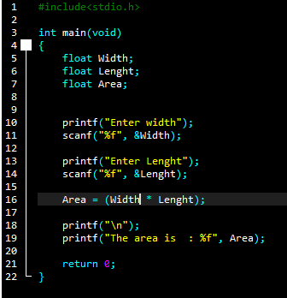

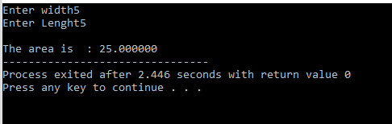

**QUESTION#9**

**Write a C program to print the following shapes using escape sequences. Moreover, you**

**are required to compile and execute these program using CMD.**

***a.***

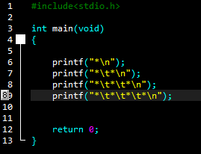



***b.***

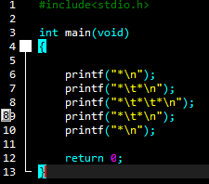

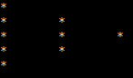

**QUESTION#10**

**For 4 months, Ali starts a diet plan to lose his weight. In the first month, he loses 5kg. In**

**the second month he loses another 10kg, In the third moth he loses another 12kg and**

**finally in the last month he loses 7kg. calculate how much weight he has lost per month,**

**on average? Also calculate his weight right now if his initial weight was 110kg?**

